**Day 2**

Eg. 2 Given the quadratic on the right (graphed), determine



1. 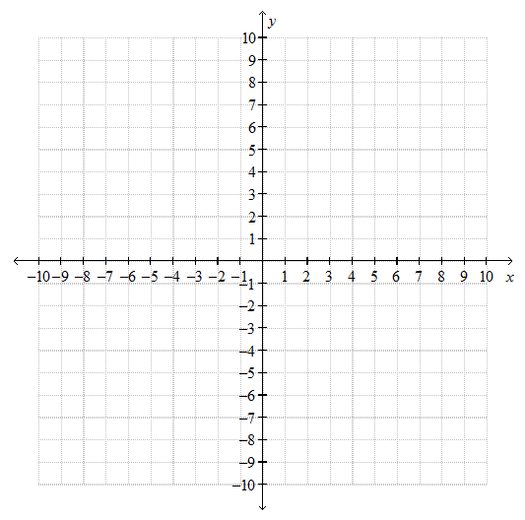the zeros



1. the equation of the axis of symmetry



1. the vertex



1. determine the equation of the parabola, in factored form $y=a(x-r)(x-s)$ (sub in what you know…and calculate …. a with algebra!)



Eg. 3. Given zeros at 3 and 7,



1. sub in what you know $y=a(x-r)(x-s)$,



then sketch a couple versions that might exist



1. are the zeros enough information?



1. Create an equation that you think might be plausible for one of your sketches



So what other information do you need with your zeros in order to find the equation?



Eg. 4 Find the equation of the parabola, in factored form if a = -2 and the x-intercepts are 8 and -6.



$y=a(x-r)(x-s)$, sub in what you know



b) Find the vertex of the quadratic.



Eg. 5. The x-intercepts of a parabola are 0 and 7 and it passes through the point (2.-30)/ Determine:



1. the equation of the parabola, in factored form.



1. the vertex

