**2.7 Using Coordinates to Solve Problems Name: _________________**



Median: ______________________________________________________________________________



Altitude: _____________________________________________________________________________



Perpendicular Bisector:_________________________________________________________________



**To find the equation of the median**



* Find the midpoint of the opposite side



* Use the vertex and midpoint to determine the slope



* Use either point to determine the y-intercept
* Put the information together in y = mx + b

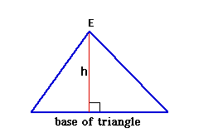**To find the equation of the altitude:**

* Find the slope of the opposite side using the vertices



* Take the negative reciprocal of the slope

Altitude

* Use the negative reciprocals and the vertex containing the altitude to determine the y-intercept
* Put the information together in y = mx + b



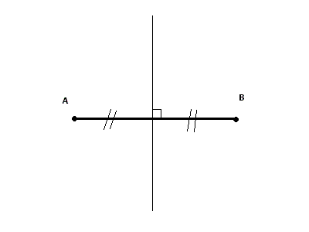**To find the equation of the perpendicular bisector:**

Perpendicular bisector

* Find the slope of the opposite side using the vertices



* Take the negative reciprocal of the slope



* Find the midpoint of the opposite side



* Use the negative reciprocal and the midpoint to determine the y-intercept
* Put the information together in y = mx + b



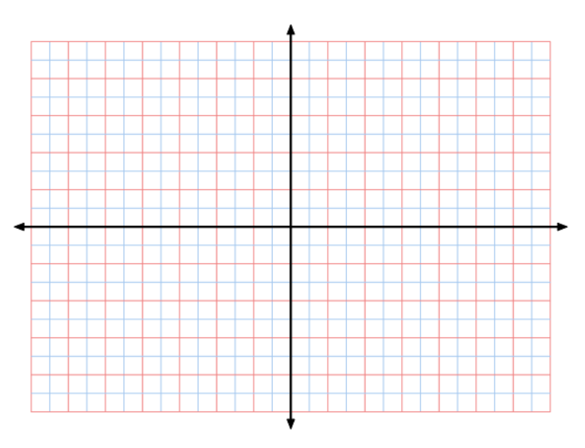**Example:**



1. Graph the triangle defined by D(10,8), E(8,-5) and F(0,9)



1. Draw the **altitude** from E on the Graph



1. Determine the **equation of the altitude**.



1. Determine the **length of the altitude** to one decimal place.



1. Draw the **perpendicular bisector** of EF on the graph.



1. Determine the **equation of this perpendicular bisector**.

